**Ideation Phase**

**Define the Problem Statements**

|  |  |
| --- | --- |
| Date | 19 September 2022 |
| Team ID | PNT2022TMID29897 |
| Project Name | PERSONAL EXPENSE TRACKER |
| Maximum Marks | 2 Marks |

**Customer Problem Statement:**

Create a problem statement to understand your customer's point of view. The Customer Problem Statement template helps you focus on what matters to create experiences people will love.

A well-articulated customer problem statement allows you and your team to find the ideal solution for the challenges your customers face. Throughout the process, you’ll also be able to empathize with your customers, which helps you better understand how they perceive your product or service.

Reference: [https://miro.com/templates/customer-problem-statement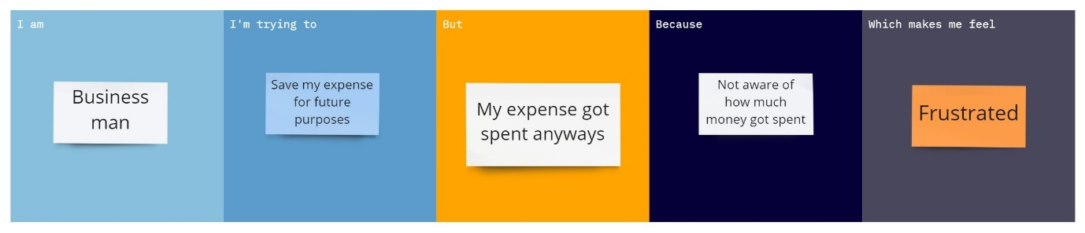](https://miro.com/templates/customer-problem-statement/)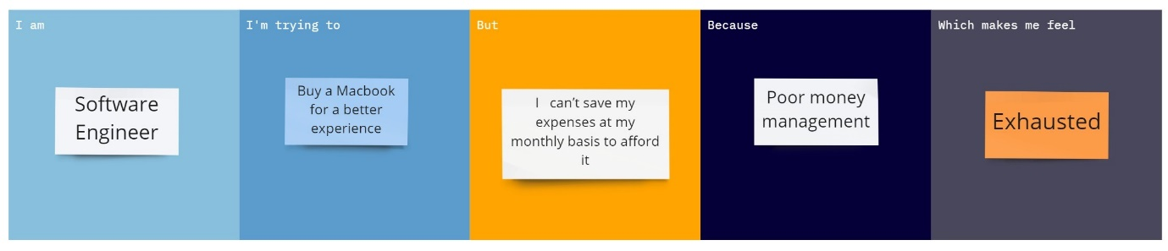

|  |  |  |  |  |  |
| --- | --- | --- | --- | --- | --- |
| **Problem Statement (PS)** | **I am (Customer)** | **I’m trying to** | **But** | **Because** | **Which makes me feel** |
| PS-1 | Business man | Save my expense for future purposes | My expense got spent anyways | Not aware of how much money got spent | Frustrated |
| PS-2 | Software Engineer | Buy a Macbook for a better experience | I can’t save my expenses at my monthly basis to afford it | Poor money management | Exhausted |